Essential

Internet of Things (IoT) with **Microsoft Azure**

Instructor Data

* Laploy Vanichangkul ลาภลอย วานิชอังกูร
* Email: laploy@gmail.com
* Phone: 084-007-5544
* home page: www.laploy.com
* Line User ID: laployv
* Skype ID: laploy

Day 1: Internet of Things

• What is IoT

• Setting up development environment

• Getting started with Microsoft Azure IoT suite

• Creating Microsoft Azure IoT hub

• Creating a device identity

• Creating device simulator

• Simulating Device-to-Cloud data telemetry

Day 2: Hardware & Software

• Hardware for IoT

• Device anatomy

• Arduino IDE primer

• Arduino Sketch Language primer

• Arduino programing and debugging

• ESP 8266 DEV board (LUNA NodeMCU)

• Getting data from Sensors

• Controlling Actuators

Day 3: Remote Monitoring

• Microsoft Azure Event Hub overview

• Creating Microsoft Azure Event Hub

• Sending messages to Microsoft Azure Event Hubs

• Alarm and response

Day 4: Device Controlling

• Microsoft Azure Service Bus

• Sending Command to Simulator

• Controlling Actuators

• Responding to acknowledgement

Day 5: Analyzing and Visualizing

• Creating and using Microsoft Azure Storage

• Creating and using Microsoft Azure Stream Analytics

• Reporting with Microsoft Power BI

• Security consideration

What is Internet of Things?

* IBM’s definition
* Intel’ definition
* Toyota’s definition
* Microsoft’s definition
* Windows and IoT

The internet of things (IoT) is the network of physical devices, vehicles, buildings and other items—embedded with electronics, software, sensors, and network connectivity that enables these objects to collect and exchange data.

Wikipedia

In the next century, planet earth will don an electronic skin. It will use the Internet as a scaffold to support and transmit its sensations.

1999 - Neil Gross in Business Week

Gartner’s definition

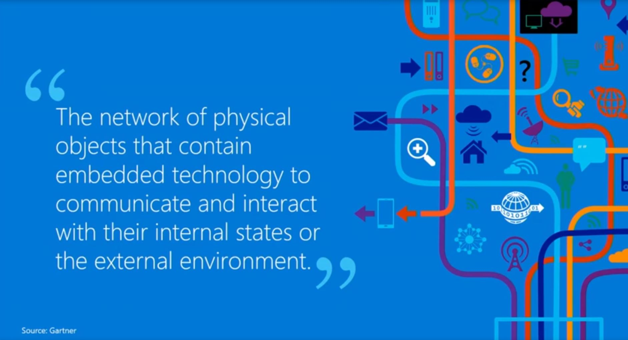

Gartner’s prediction over number of device

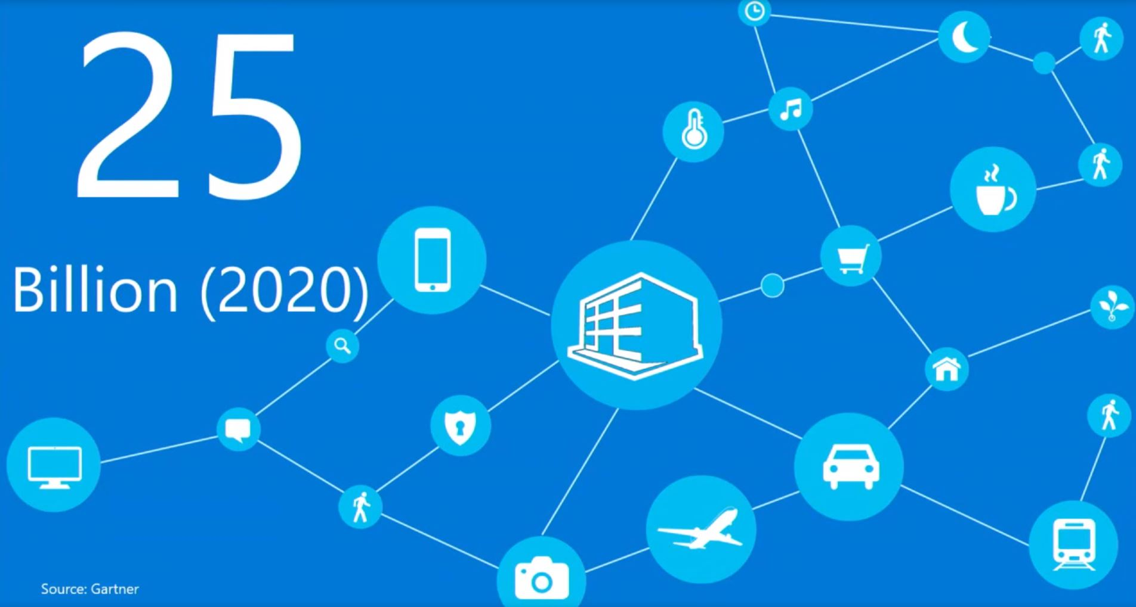

Internet of Things Platform

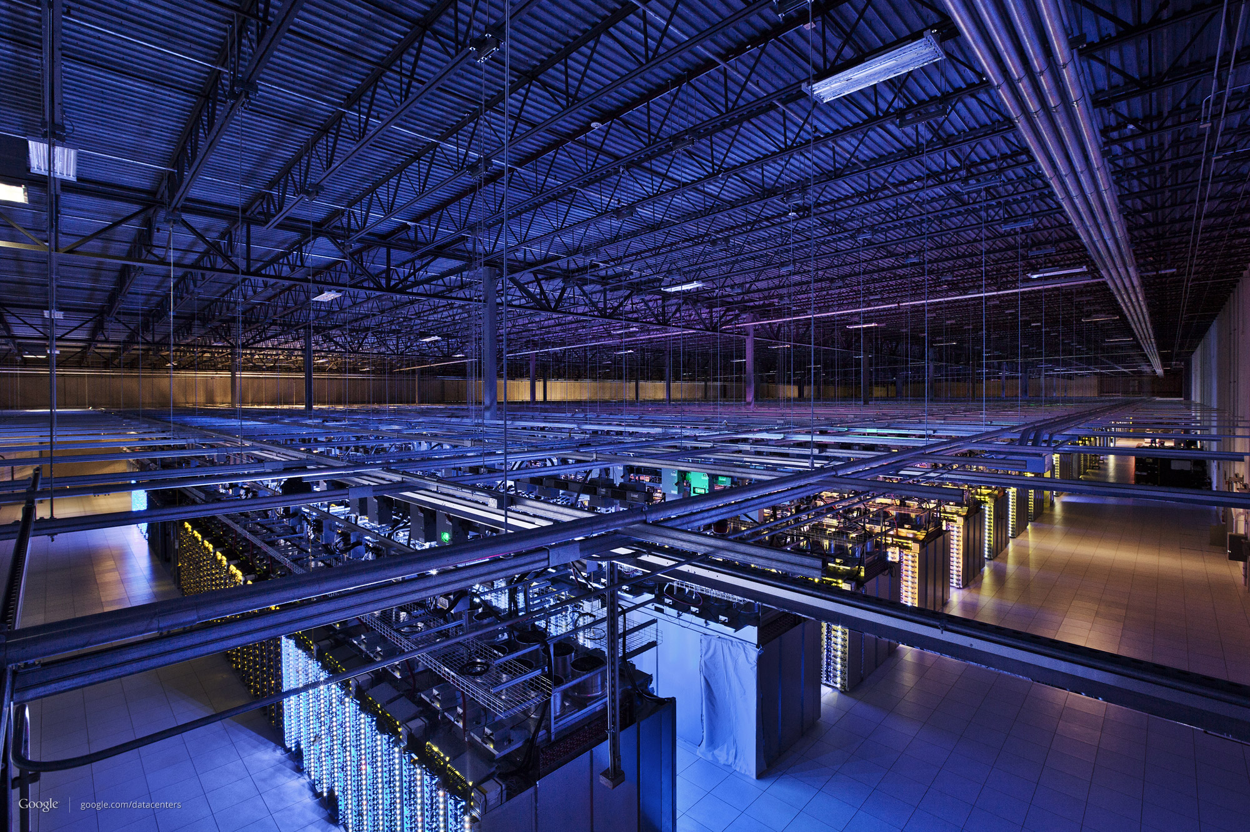

IBM

Watson Internet of Things. Cognitive Internet of Things will transform the way every person experiences the physical world.

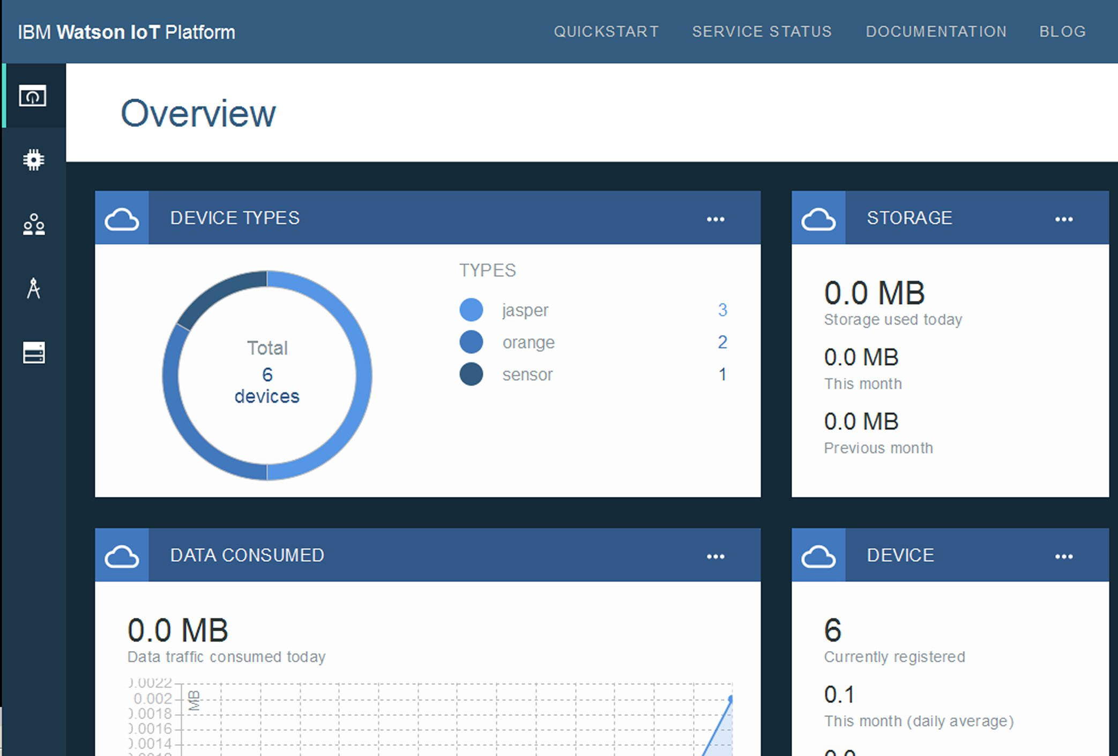

Google

Google Brillo. brings the simplicity and speed of software development to hardware for IoT with an embedded OS, core services, developer kit, and developer console.

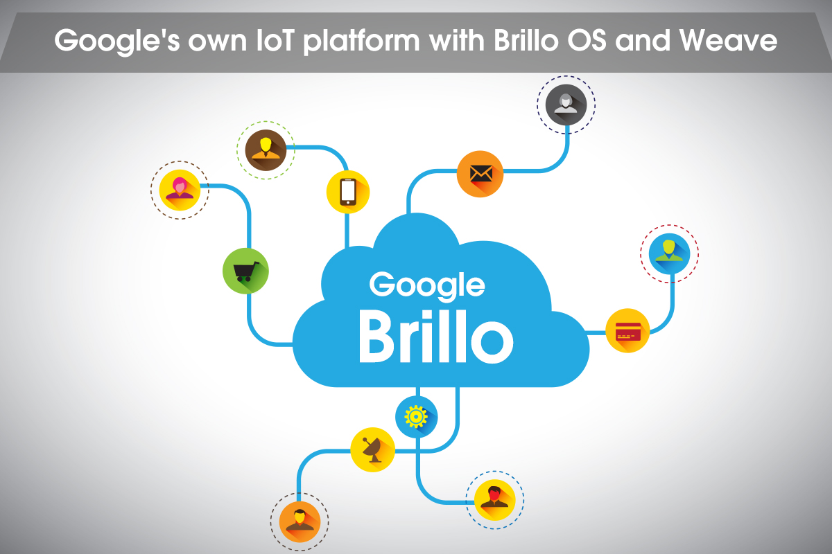

amazon

amazon AWS IoT. Easily and securely connect devices to the cloud.

Reliably scale to billions of devices and trillions of messages

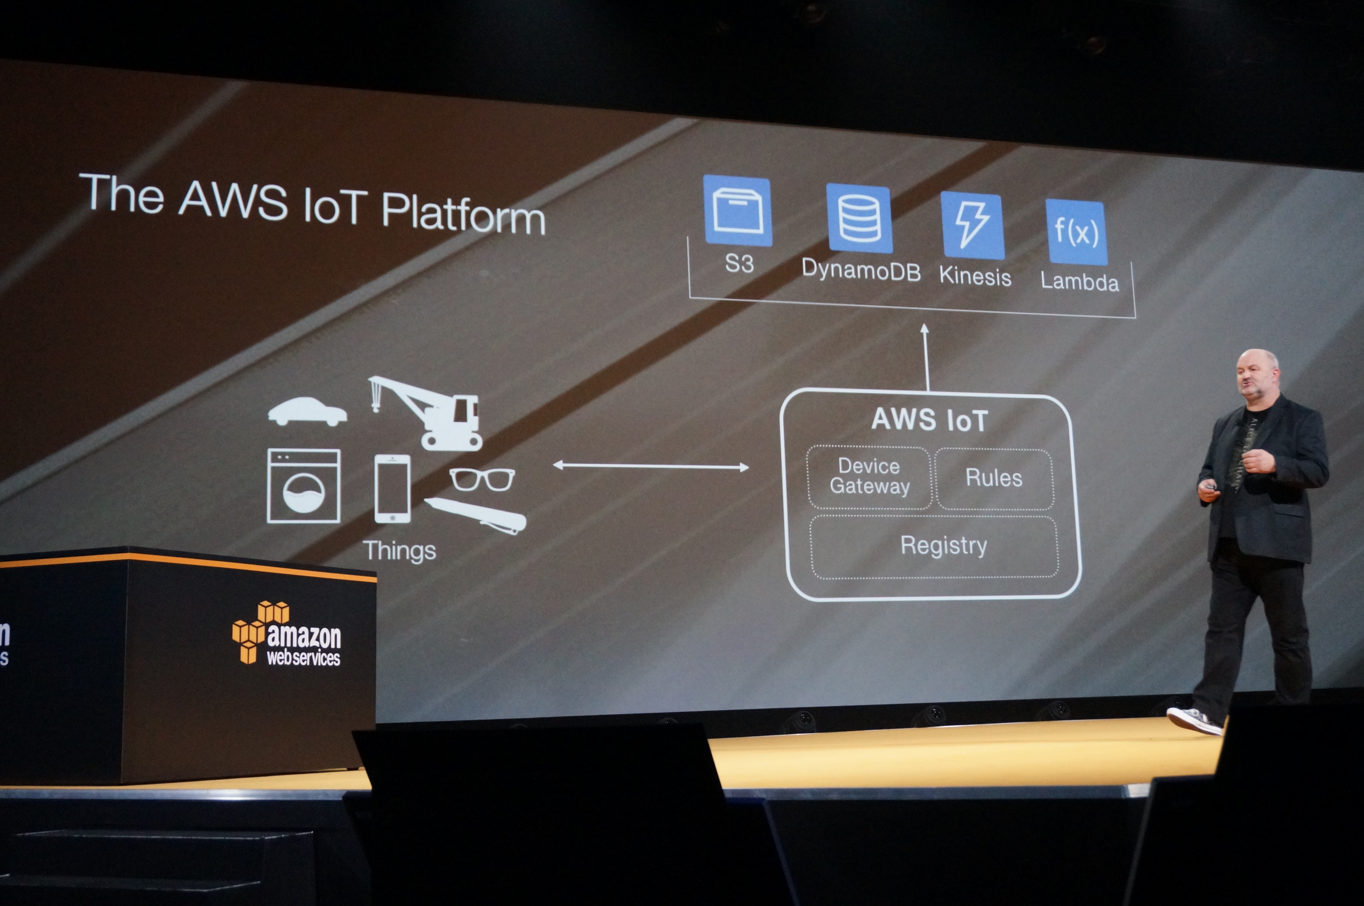

Microsoft

Microsoft Azure IoT Suite. Capture and analyze untapped data to improve business results

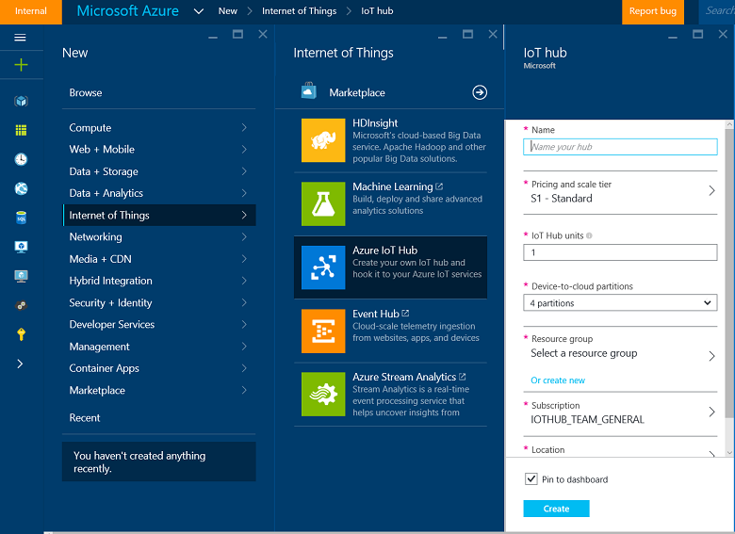

Cloud Market Share

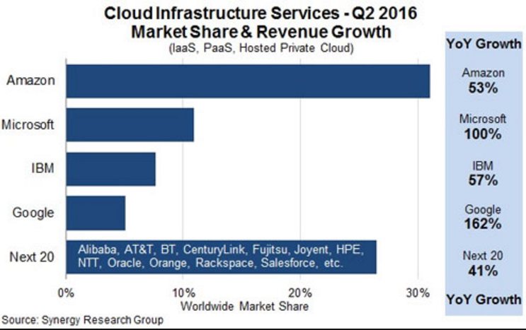

Brief History of IoT

When wireless is perfectly applied the whole earth will be converted into a huge brain, which in fact it is, all things being particles of a real and rhythmic whole

1926: Nikola Tesla



1966: Karl Steinbuch a German computer science pioneer said "In a few decades time, computers will be interwoven into almost every industrial product"

1969: Arpanet

1974: Beginnings of TCP/IP

1984: Domain Name System is introduced

1989: Tim Berners-Lee proposes the World Wide Web

1990: John Romkey created the first Internet ‘device’, a toaster that could be turned on and off over the Internet.

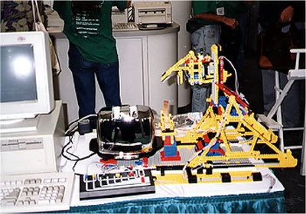

1999: The Internet of Things term is coined by Kevin Ashton

2000: LG announces it's first Internet refrigerator plans.

2006: First European IOT conference is held

2007: IPSO alliance including Bosch, Cisco, Ericsson, Intel, SAP, Sun, Google and Fujitsu.

2008: The Internet of Things was "Born"

2011: IPV6 public launch

The most profound technologies are those that disappear.

Mark Weiser – Xerox PARC

IoT Application

Smart Cities

* Smart Parking: Monitoring of parking spaces availability in the city.
* Structural health: Monitoring of vibrations and material conditions in buildings, bridges and historical monuments.
* Noise Urban Maps: Sound monitoring in bar areas and centric zones in real time.
* Smartphone Detection: Detect iPhone and Android devices and in general any device which works with WiFi or Bluetooth interfaces.
* Electromagnetic Field Levels: Measurement of the energy radiated by cell stations and WiFi routers.
* Traffic Congestion: Monitoring of vehicles and pedestrian levels to optimize driving and walking routes.
* Smart Lighting: Intelligent and weather adaptive lighting in street lights.
* Waste Management: Detection of rubbish levels in containers to optimize the trash collection routes.
* Smart Roads: Intelligent Highways with warning messages and diversions according to climate conditions and unexpected events like accidents or traffic jams.

Smart Environment

* Forest Fire Detection: Monitoring of combustion gases and preemptive fire conditions to define alert zones.
* Air Pollution: Control of CO2 emissions of factories, pollution emitted by cars and toxic gases generated in farms.
* Landslide and Avalanche Prevention: Monitoring of soil moisture, vibrations and earth density to detect dangerous patterns in land conditions.
* Earthquake Early Detection: Distributed control in specific places of tremors.

Smart Water

* Potable water monitoring: Monitor the quality of tap water in cities.
* Chemical leakage detection in rivers: Detect leakages and wastes of factories in rivers.
* Swimming pool remote measurement: Control remotely the swimming pool conditions.
* Pollution levels in the sea: Control real-time leakages and wastes in the sea.
* River Floods: Monitoring of water level variations in rivers, dams and reservoirs.

Smart Metering

* Smart Grid: Energy consumption monitoring and management.
* Tank level: Monitoring of water, oil and gas levels in storage tanks and cisterns.
* Photovoltaic Installations: Monitoring and optimization of performance in solar energy plants.
* Water Flow: Measurement of water pressure in water transportation systems.
* Silos Stock Calculation: Measurement of emptiness level and weight of the goods.

Security & Emergencies

* Perimeter Access Control: Access control to restricted areas and detection of people in non-authorized areas.
* Liquid Presence: Liquid detection in data centers, warehouses and sensitive building grounds to prevent break downs and corrosion.
* Radiation Levels: Distributed measurement of radiation levels in nuclear power stations surroundings to generate leakage alerts.
* Explosive and Hazardous Gases: Detection of gas levels and leakages in industrial environments, surroundings of chemical factories and inside mines.

Retail

* Supply Chain Control: Monitoring of storage conditions along the supply chain and product tracking for traceability purposes.
* NFC Payment: Payment processing based in location or activity duration for public transport, gyms, theme parks, etc.
* Intelligent Shopping Applications: Getting advices in the point of sale according to customer habits, preferences, presence of allergic components for them or expiring dates.
* Smart Product Management: Control of rotation of products in shelves and warehouses to automate restocking processes.

Logistics

* Quality of Shipment Conditions: Monitoring of vibrations, strokes, container openings or cold chain maintenance for insurance purposes.
* Item Location: Search of individual items in big surfaces like warehouses or harbors.
* Storage Incompatibility Detection: Warning emission on containers storing inflammable goods closed to others containing explosive material.
* Fleet Tracking: Control of routes followed for delicate goods like medical drugs, jewels or dangerous merchandises.

Industrial Control

* M2M Applications: Machine auto-diagnosis and assets control.
* Indoor Air Quality: Monitoring of toxic gas and oxygen levels inside chemical plants to ensure workers and goods safety.
* Temperature Monitoring: Control of temperature inside industrial and medical fridges with sensitive merchandise.
* Ozone Presence: Monitoring of ozone levels during the drying meat process in food factories.
* Indoor Location: Asset indoor location by using active (ZigBee) and passive tags (RFID/NFC).
* Vehicle Auto-diagnosis: Information collection from CanBus to send real time alarms to emergencies or provide advice to drivers.

Agriculture

* Green Houses: Control micro-climate conditions to maximize the production of fruits and vegetables and its quality.
* Golf Courses: Selective irrigation in dry zones to reduce the water resources required in the green.
* Meteorological Station Network: Study of weather conditions in fields to forecast ice formation, rain, drought, snow or wind changes.
* Compost: Control of humidity and temperature levels in alfalfa, hay, straw, etc. to prevent fungus and other microbial contaminants.

Animal Farming

* Hydroponics: Control the exact conditions of plants grown in water to get the highest efficiency crops.
* Offspring Care: Control of growing conditions of the offspring in animal farms to ensure its survival and health.
* Animal Tracking: Location and identification of animals grazing in open pastures or location in big stables.
* Toxic Gas Levels: Study of ventilation and air quality in farms and detection of harmful gases from excrements.

Domestic & Home Automation

* Energy and Water Use: Energy and water supply consumption monitoring to obtain advice on how to save cost and resources.
* Remote Control Appliances: Switching on and off remotely appliances to avoid accidents and save energy.
* Intrusion Detection Systems: Detection of windows and doors openings and violations to prevent intruders.
* Art and Goods Preservation: Monitoring of conditions inside museums and art warehouses.

eHealth

* Fall Detection: Assistance for elderly or disabled people living independent.
* Medical Fridges: Control of conditions inside freezers storing vaccines, medicines and organic elements.
* Sportsmen Care: Vital signs monitoring in high performance centers and fields.
* Patients Surveillance: Monitoring of conditions of patients inside hospitals and in old people's home.
* Ultraviolet Radiation: Measurement of UV sun rays to warn people not to be exposed in certain hours.

Internet of Things

Application examples

Walmart

* Retailing giant Walmart heavily uses big data for consumer insights and store-level merchandising.

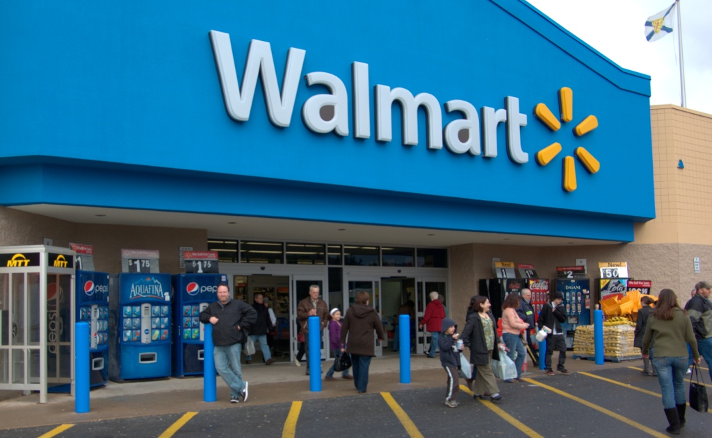

* The company mines social media trends to showcase types of products that are rising in popularity, and local weather data is compared against historical sales data to boost grocery sales.
* For example, Walmart’s data shows sales for salad ingredients rise when the forecast suggests temperatures above 80 and light winds

Disney

* Disney has RFID-enabled MagicBand wristbands that provide theme park access, entry access for guest hotel rooms, and cash and card-free payment food and merchandise.

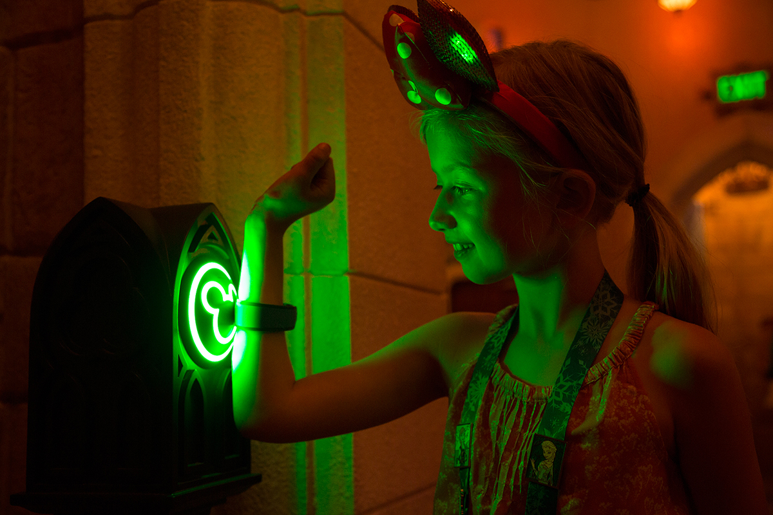

* All that activity is also tracked data that helps build a better picture of how guests use Disney services.

amazon

* Online retailing giant Amazon is once again disrupting bricks and mortar retailing with the Dash Button, a WiFi enabled device that is mapped to specific consumer packaged goods products like laundry detergent.

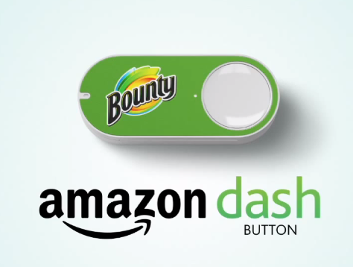

* Stuck to a washing machine, all a consumer needs to do when the current supply is running low is tap the button and that generates an order, transaction and delivery of a fresh supply of detergent.

Knocki

* is a device that fastens onto tables, walls, and doors.
* 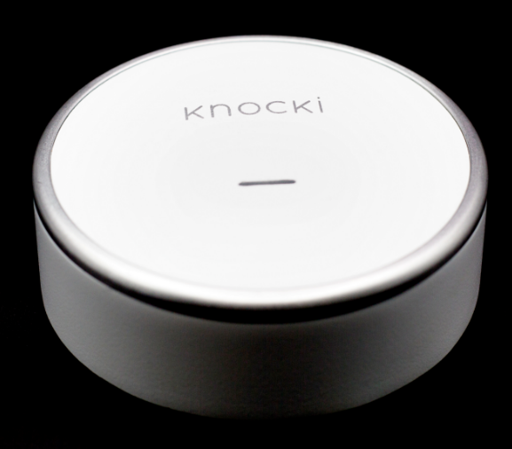It then translates taps and knocks into controls for your Internet of Things devices.
* It essentially turns whatever you stick it to into a remote control.
* For example, you can tap on a table three times to dim the lights and turn on the TV.

Mesh

* a DIY kit of small, wireless tags that attach to anything you want to make a little smarter.
* Stick a motion sensor tag on your door and get a push notification when it opens.

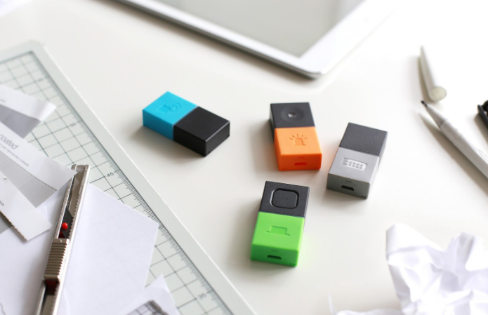

Iris: Smart Home Watering System

* Works with the Iris home management system (Iris smart hub required)
* 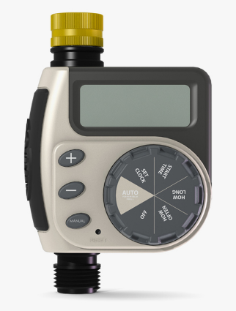Control your timer's watering schedule from your computer or smart phone
* Large easy-to-read digital display
* Easy to program
* Connects to a standard hose faucet

Roost

Smart Fire Alarm Texts You if It Smells Smoke

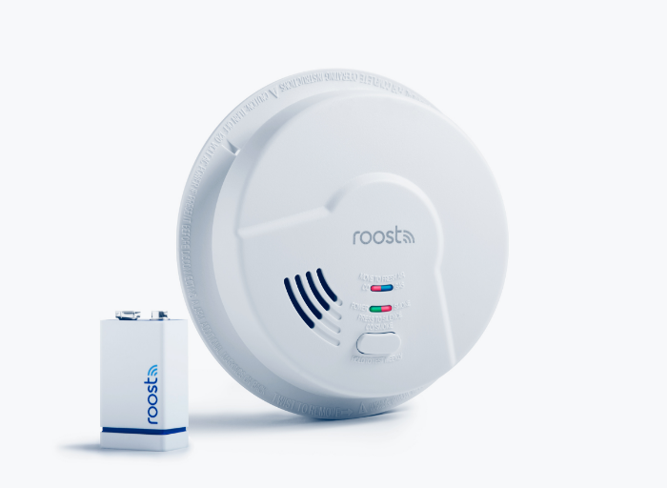

Artificial Nose “Smells” When Food Is About to Go Bad

* 4 sensing elements,
* detect up to 4 compounds at the same time,
  + Ethylene for fruit freshness,
  + biogenic amines for meat/fish/poultry freshness,
  + Humidity
  + 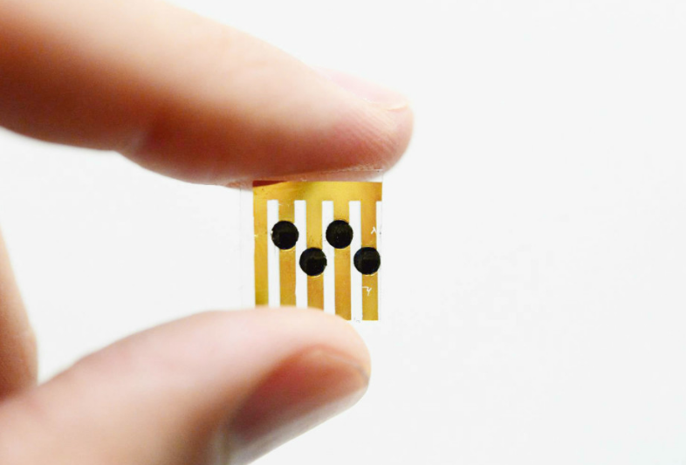Carbon dioxide.

Top 10 IoT applications

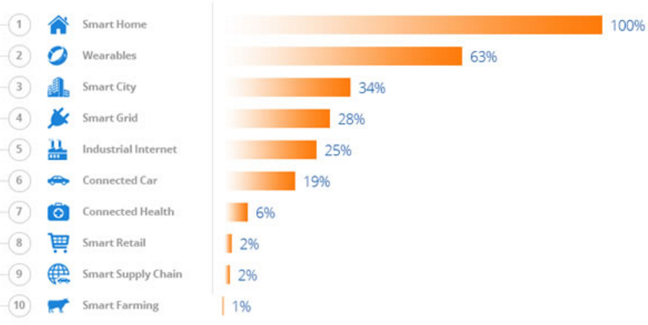

**Setting up development environment**



Visual Studio 2017



Arduino Software IDE



Visual Studio setup

1. Make sure you are running the public release of Windows 10 (version 10.0.10240) or newer.
2. Install Visual Studio Community 2017 or Visual Studio Professional 2017 or Visual Studio Enterprise 2017

http://go.microsoft.com/fwlink/?LinkID=534599

1. If custom install; select the checkbox Universal Windows App Development Tools -> Tools and Windows SDK.
2. Update Visual Studio 2017. If you already have Visual Studio 2017 installed, install Update.
3. Validate your Visual Studio installation. Selecting Help > About Microsoft Visual Studio will display version information. The required version of Visual Studio is 15.2. Newer version is better.

Arduino setup

* Get an Arduino board and USB cable
* Download and install the Arduino Software (IDE)
* Connect the board
* Install the board drivers
* Launch the Arduino Software (IDE)
* Open the blink example
* Select your board
* Select your serial port
* Upload the program
* Check the result

Get an Arduino board and USB cable

Arduino compatible board

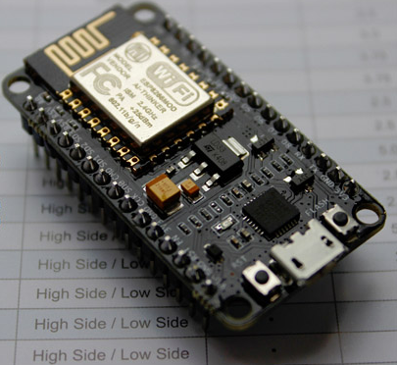

Micro USB cable

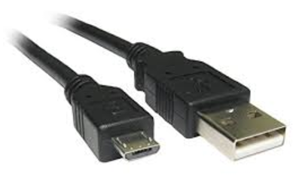

Download and install the Arduino Software (IDE)

https://www.arduino.cc/en/Main/Software

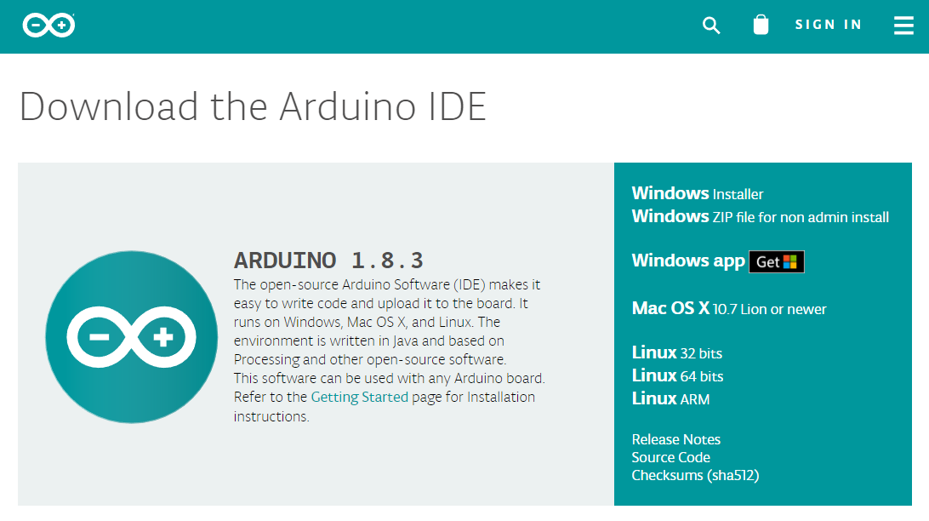

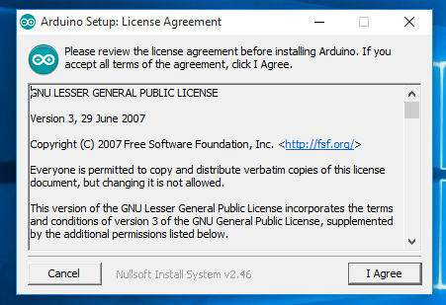

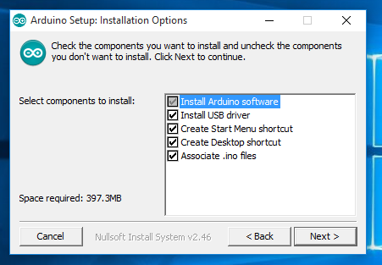

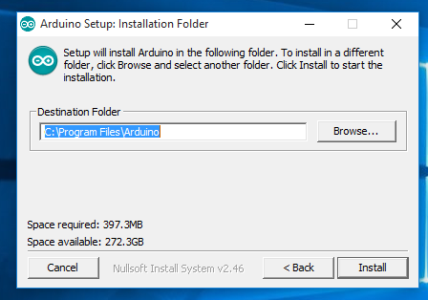

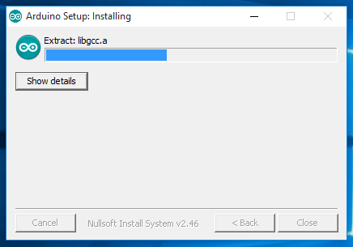

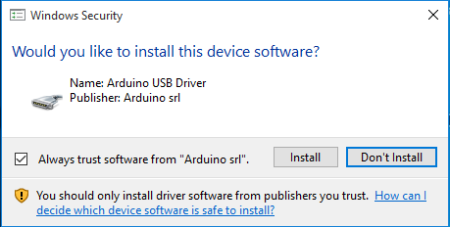

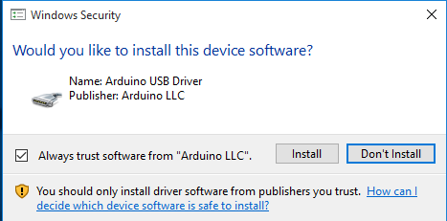

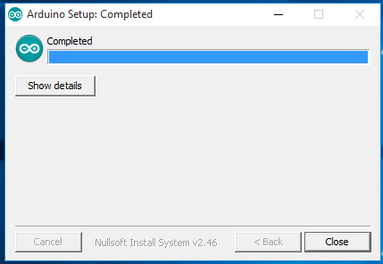

Install the board drivers

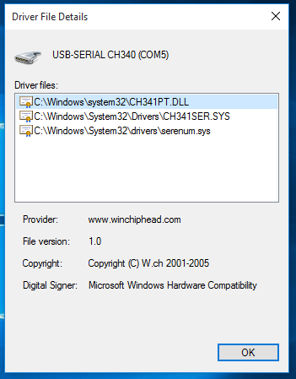Windows will install drivers automatically as soon as you connect your board.

Confirm driver installation

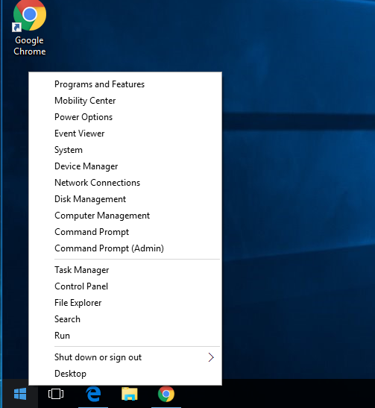

* Plug USB cable to board
* Plug USB cable to PC
* Right Click at “Windows Start Button”
* Select Device Manager

Device Manager Window

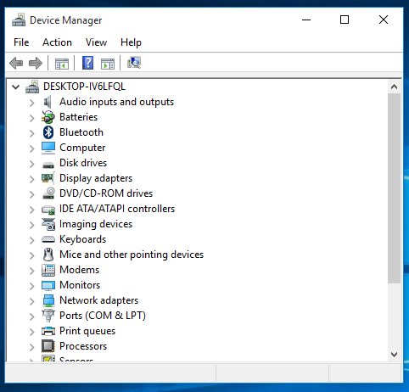

USB-SERIAL CH340.

Note Com number

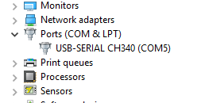

Open program Arduino IDE

Allow access Firewall

Arduino software is ready

Set Communication Port

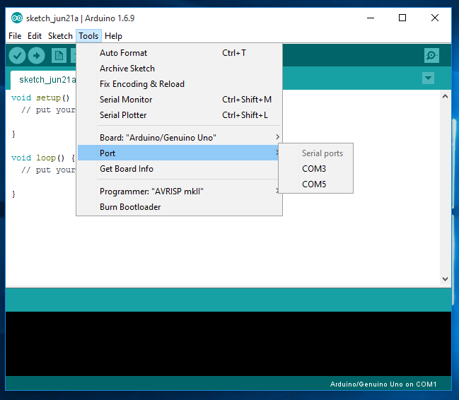

Set Board to NodeMCU 1.0 (ESP-12E Module)

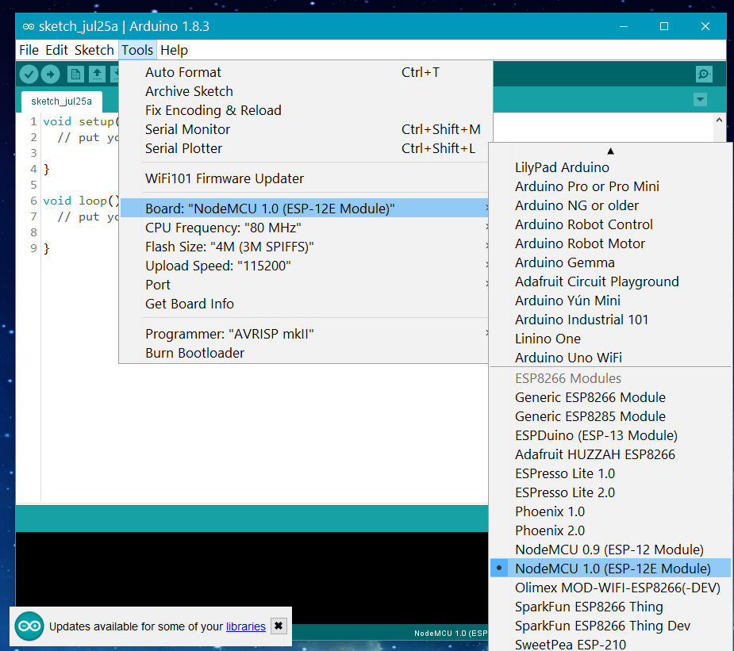

Open Examples / 01. Basics / Blink

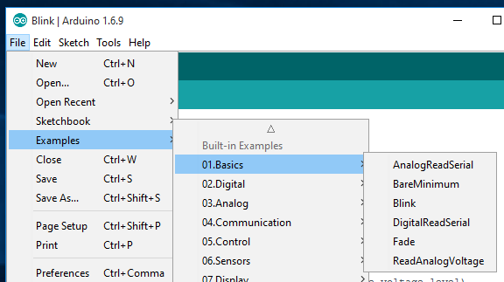

Arduino Development Environment Test

* Verify Program
* Upload Program
* Modify Program

More information on Arduino Software

* Getting Started with Arduino and Genuino on Windows

https://www.arduino.cc/en/Guide/Windows

* Arduino Software (IDE)

https://www.arduino.cc/en/Guide/Environment

Microsoft Azure Subscription

1. Microsoft Account Sign-up
2. Redeem your Azure Pass Promo Code
3. Activate your Azure subscription

Microsoft Power BI Subscription

1. Sign-up
2. Enter Work Email / Check Mail
3. Create New Account

Microsoft Azure Trial

https://azure.microsoft.com/en-us/free

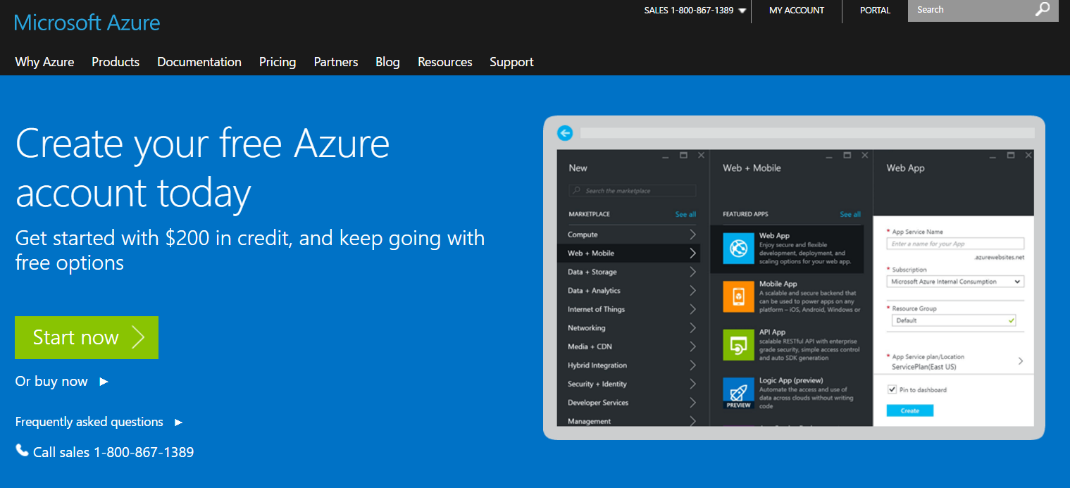Get up to 3,000 free messages per day allowing you to monitor

and control up to 10 of your IoT devices.

Visual Studio Dev Essentials

https://www.visualstudio.com/en-us/products/visual-studio-dev-essentials-vs.aspx

Azure credit ($25/month for 12 months)

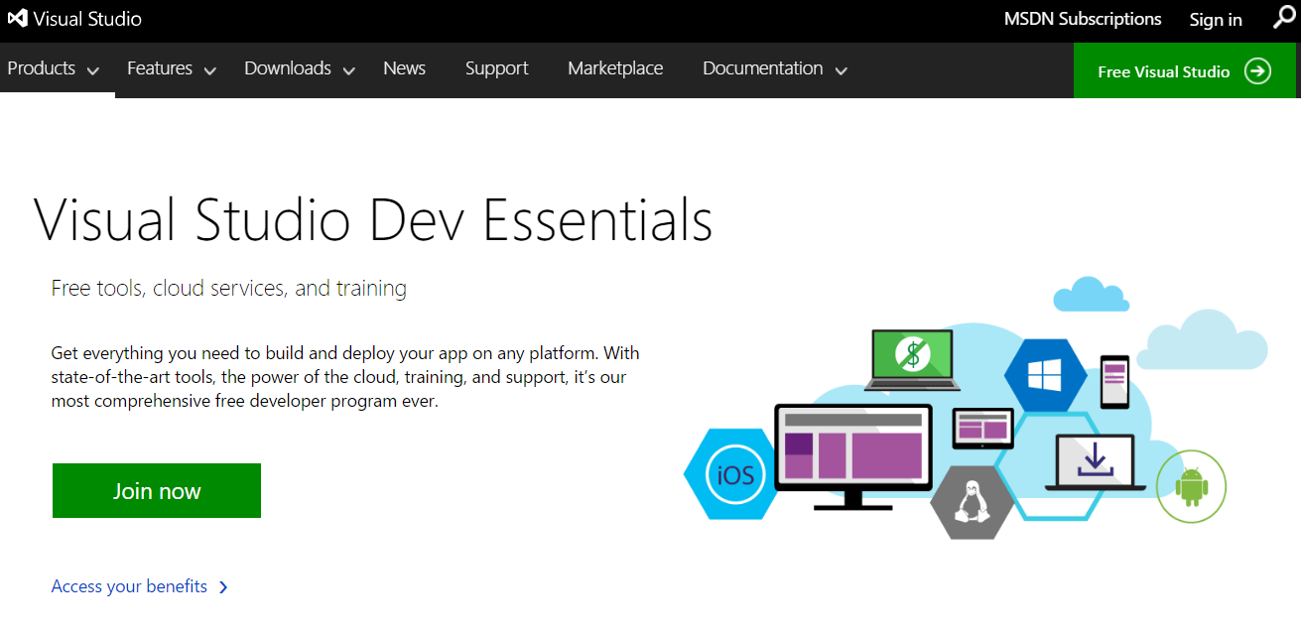

Microsoft Account Sign-up

https://account.microsoft.com/about

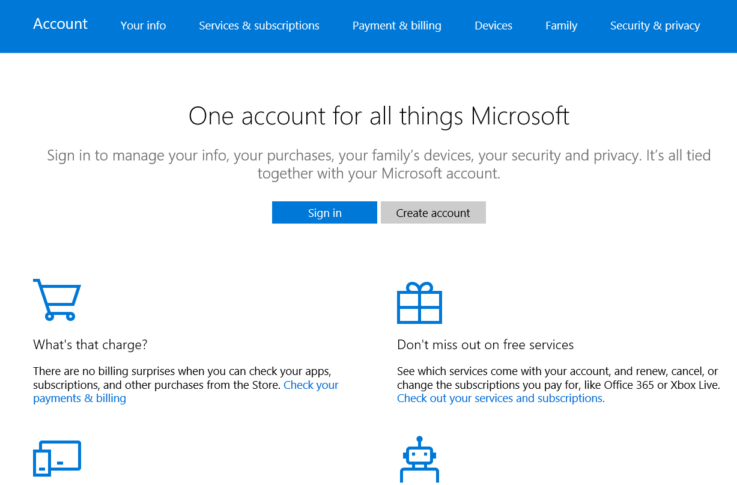

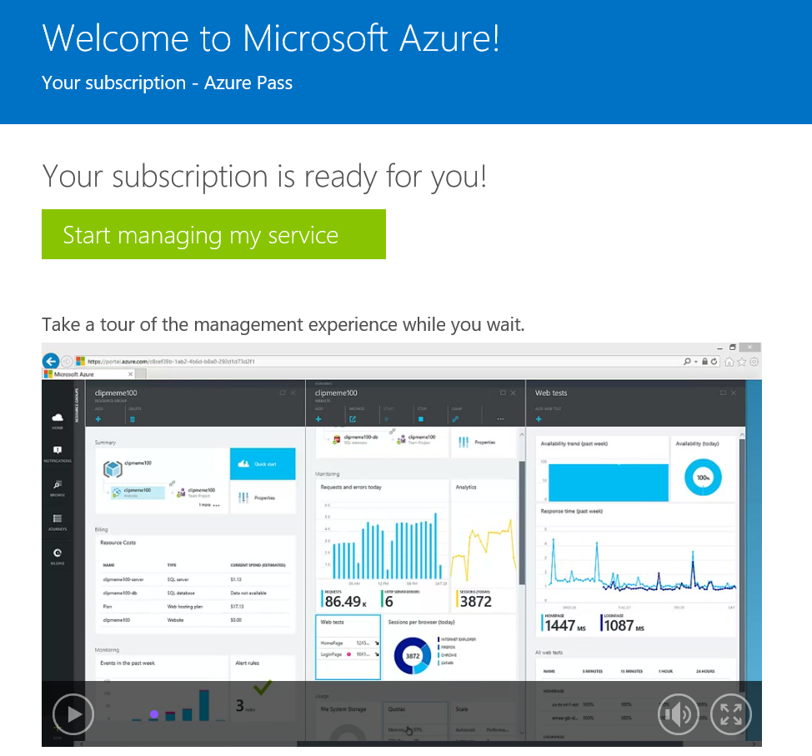

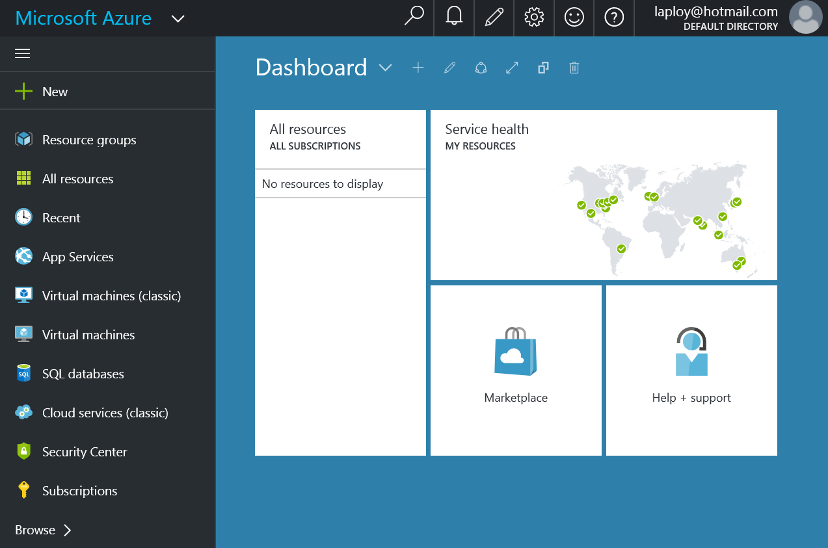

Microsoft Power BI

https://powerbi.microsoft.com/en-us/

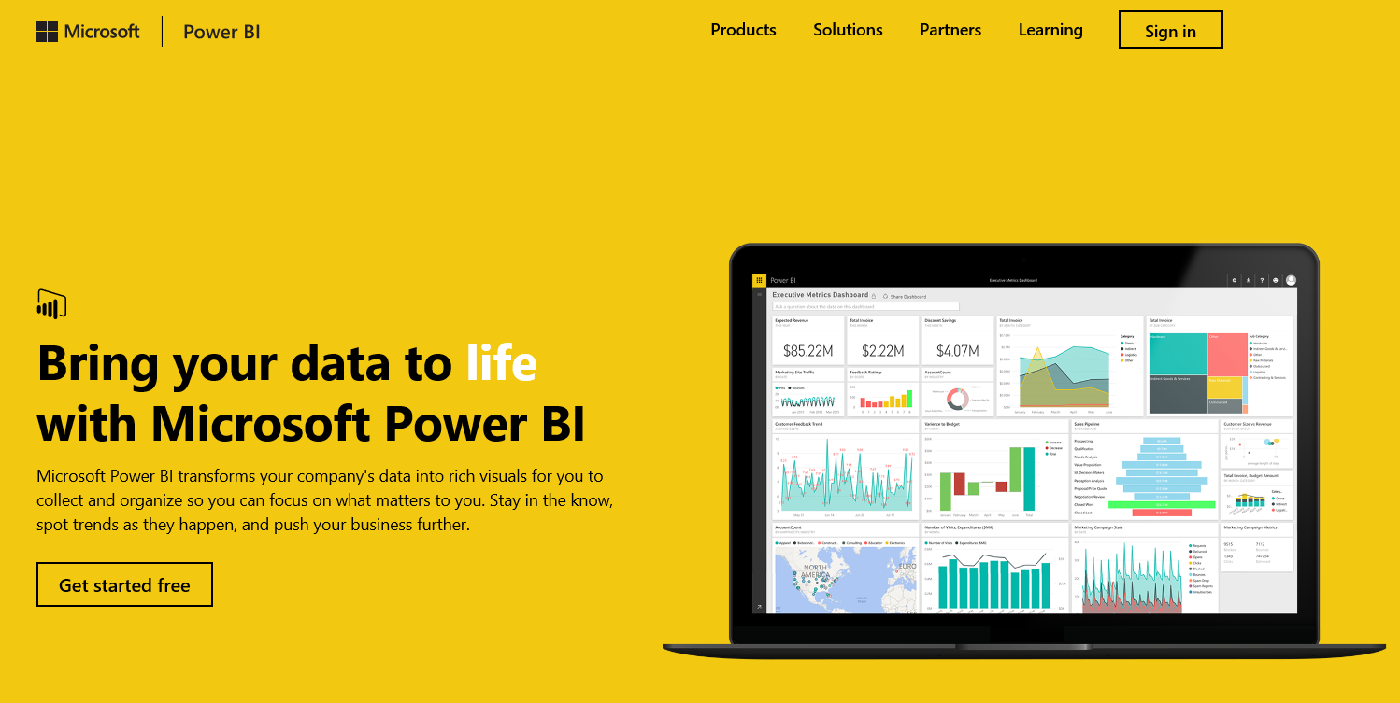

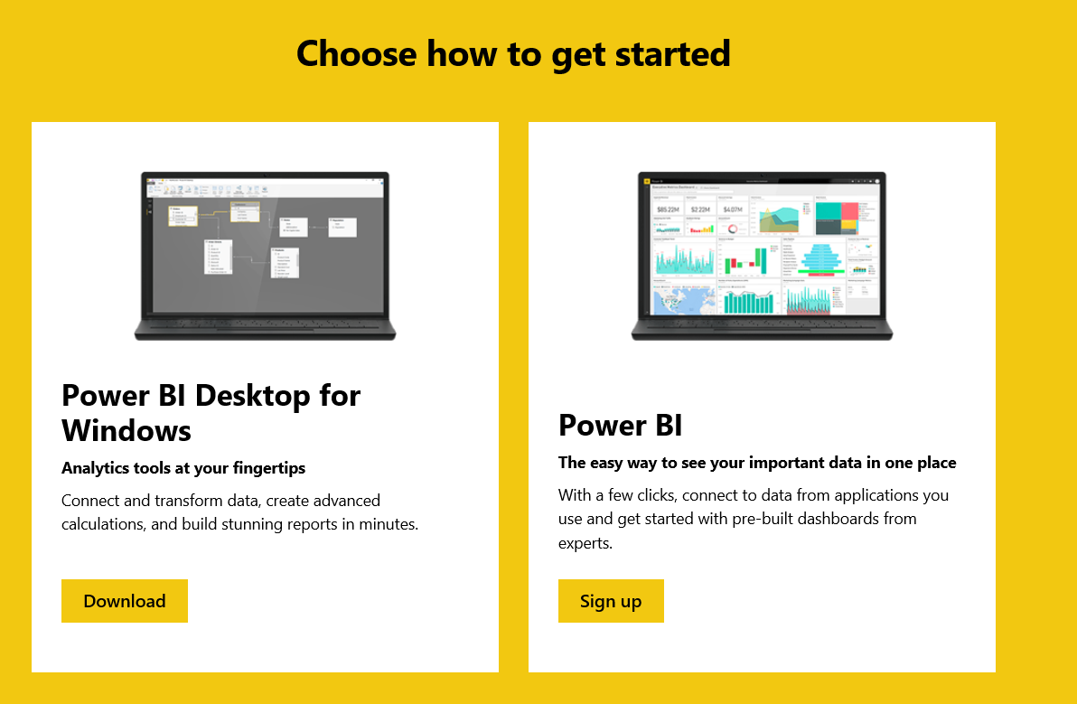

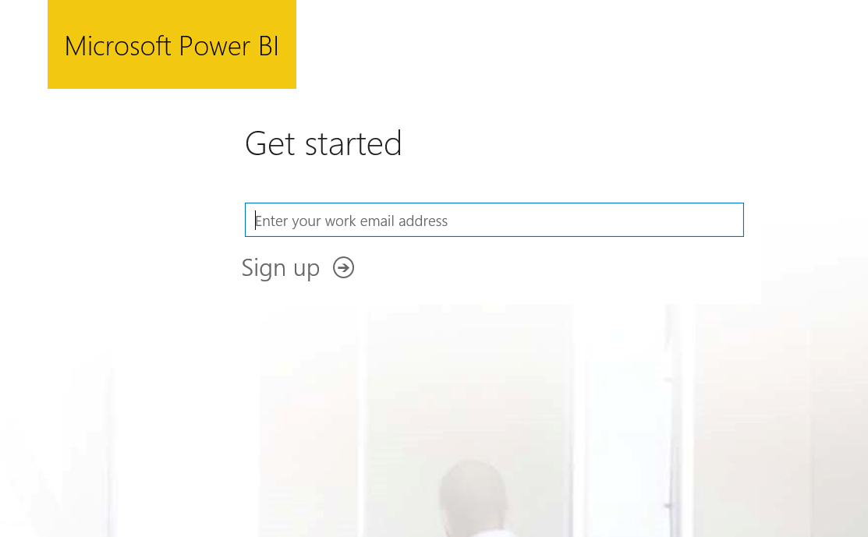

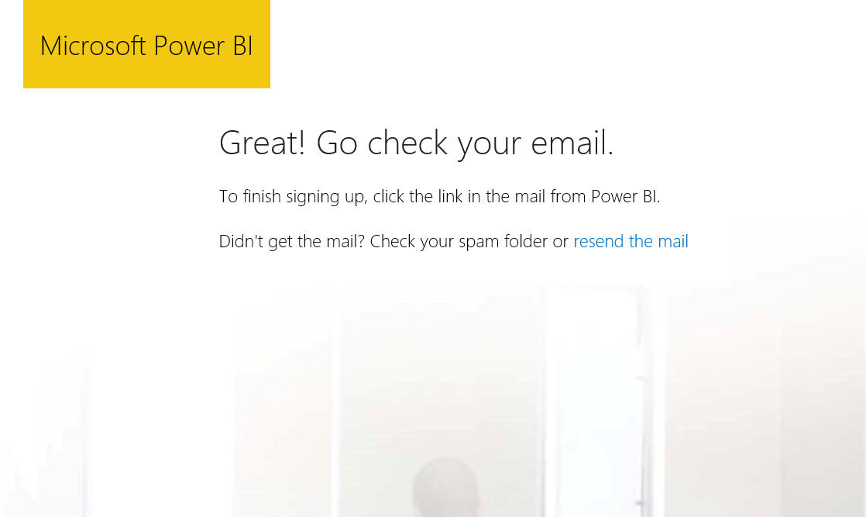

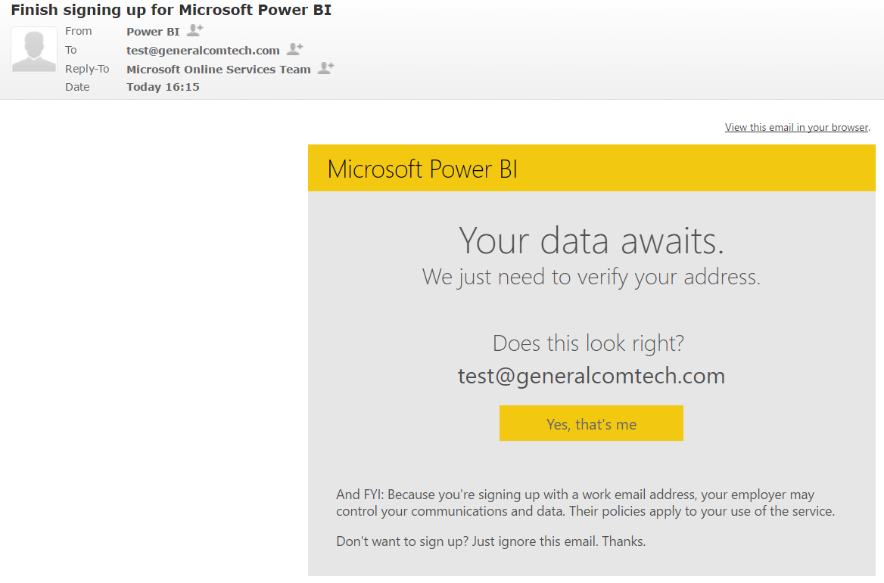

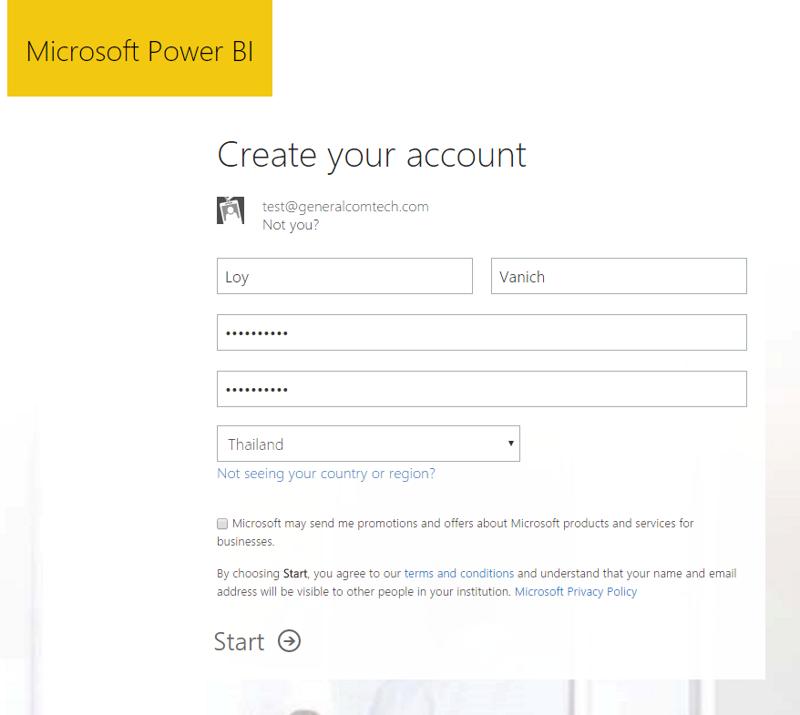

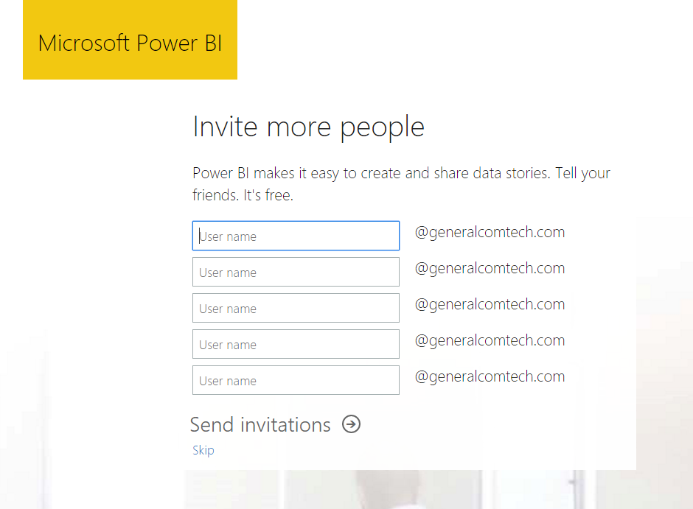

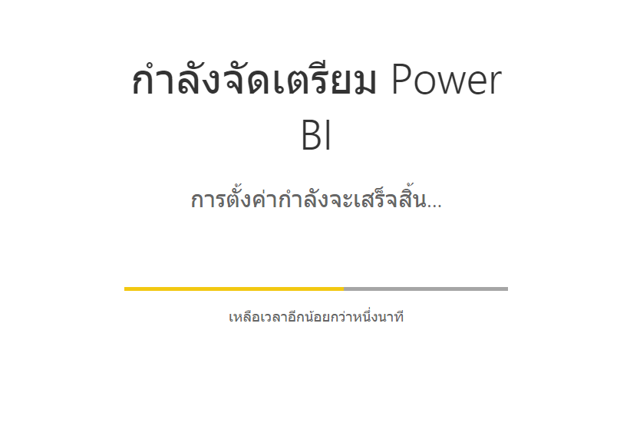

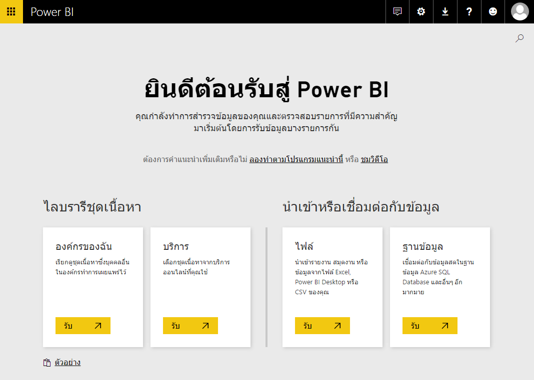

More on Azure Subscription

* How to buy Azure

https://azure.microsoft.com/en-us/pricing/purchase-options/

* Azure subscription and service limits, quotas, and constraints

https://azure.microsoft.com/en-us/documentation/articles/azure-subscription-service-limits/

More on Microsoft Power BI Sign Up

* Power BI Sign Up Walkthrough

https://powerbi.microsoft.com/en-us/blog/power-bi-sign-up-walkthrough/